Evaluation of Secondary School Laboratory Manager role
Report prepared for the Post Primary Teachers’ Association on an evaluation of the role of Secondary School Laboratory Manager

Author: Geoff Summers
Business Consultant
March 2023

Table of Contents
Appreciation 1
Executive Summary 2
Recommendations 3
Background 4
Survey 4
Question 1 – Full-time or Part-time 4
Question 2 – Reason for holding the role 5
Question 3 – Time spent on the Laboratory Manager role 5
Question 4 – Support from the School Principal 5
Question 5 – Support from the Board of Trustees 6
Question 6 – Effectiveness of Ministry guidance document 6
Question 7 – Technical skill requirements 7
Question 8 – Communications skill requirements 7
Question 9 – Intellectual skill requirements 8
Question 10 – Leadership skill requirements 8
Question 11 – Physical skill requirements 9
Question 12 – Formal qualification requirements 9
Question 13 – Formal experience requirements 9
Question 14 – Monetary reward received 9
Question 15 – Other relevant comments 9
Survey conclusions 10
Health and Safety 10
Recommendations 11
Recruitment of Laboratory Managers 11
Job description 12
Time allocation 12
Professional development 12
Ministry guidance 12
Recommendations 13
Monetary reward 13
Survey outcomes 13
Evaluation basis 14
Key results 14
Skills usage 15
Expertise requirements 16
Overall conclusion on evaluation 16
Recommendations 17

Table of Figures
Figure 1 - Responses relating to full vs part-time 5
Figure 2 - Reasons for holding the Laboratory Manager role 5
Figure 3 - Support from Principals 6
Figure 4 - Support from the BOT 6
Figure 5 - Monetary reward received 9
Figure 6 - Simple job design model 14

Appreciation
This report utilised a survey of Laboratory Managers as the primary means of obtaining accurate information about their role. 69 Laboratory Managers confidentially responded to the survey and their input was valuable and much appreciated by the Consultant. One Laboratory Manager also had a confidential telephone conversation with the Consultant and that person’s additional input was also much appreciated.

Executive Summary

This report, commissioned by the PPTA, outlines the results of a survey of Laboratory Managers as a means of gaining information needed to evaluate the role of Laboratory Manager in secondary schools. The information obtained highlighted a number of concerns:
- There is a lack of compliance with the Health and Safety at Work Act 2015 by some Boards of Trustees and Principals in relation to those officers’ responsibilities as a person conducting a business or undertaking (PCBU); and
- The role of Laboratory Manager is not a career enhancing role because of the means whereby it is deployed within many schools (through the incumbents undertaking the role because there was no-one else prepared to do the work or because they were in some way coerced into the role); and
- There is not an appropriate job description for the role of Laboratory Manager; and
- Many Laboratory Managers have not been provided with the legislative right to bargain for suitable terms and conditions including agreed appropriate time allowance to perform the role; and
- There is a lack of appropriate professional development provided to many Laboratory Managers;
- The Ministry of Education’s document, “Safety and Science/Pūtaiao - Guidance for Aotearoa New Zealand Schools and Kura”, requires updating; and
- There is lack of uniformity in how Laboratory Managers are paid for the work that they perform.
The evaluation of the role of Laboratory Manager concluded that the role is similar in terms of deliverables, responsibility and expertise needs to that of a Science HOD and therefore many of the incumbents in that role are being underpaid for the Laboratory Manager part of their work.
Twelve detailed recommendations are made to rectify the concerns highlighted along with methods and suggested relativities for paying Laboratory Managers for their work.

Recommendations
The Consultant recommends that the PPTA:
- Note the survey respondents’ reported lack of compliance with PCBU obligations by many Boards of Trustees and Principals in relation to school laboratories (paragraph 34.1); and
- Urgently bring this to the attention of: (i) the Secretary for Education; (ii) any PPTA members who are Principals; (iii) any other organisation that represents other Principals; and (iv) the New Zealand Schools Trustees Association (paragraph 34.2); and
- Remind them all that BOTs and Principals are Officers of PCBUs under the Health and Safety at Work Act 2015 and they have onerous obligations relating to the school laboratories so urgent action is needed to rectify the reported non-compliance where it exists (paragraph 34.3); and
- Work with the appropriate people to completely redesign the role of Laboratory Manager (as outlined in paragraph 36 of this report) to become a career enhancing role that would be challenging but satisfying for staff with appropriate expertise thereby enabling the recruitment of knowledgeable, highly motivated and willing staff to the role (paragraph 44.1); and
- Work with the appropriate people to prepare a job description for the role of Laboratory Manager, preferably incorporating an ability to take into account differences caused by size, location, full or part-time or other important factors (including whether or not it the role could be undertaken by a Laboratory Technician), clearly providing the role incumbents with the necessary information and authority to undertake the role effectively (paragraph 44.2); and
- Initiate bargaining under s.61(1) of the Employment Relations Act 2000 for any PPTA members who are Laboratory Managers to document a fair set of terms and conditions for the role including appropriate time allowance as required by s.67C(1)(a)(ii) of that Act (paragraph 44.3); and
- Work with all authorities that are PCBUs under the Health and Safety at Work Act 2015 in secondary schools to implement s.36(3)(f) of that Act to provide appropriate information and professional development to assist the Laboratory Managers to fully understand and complete their role in a manner that is compliant with all laws and regulations including the development and provision of an appropriate qualification for Laboratory Managers (paragraph 44.4); and
- Work with the Ministry to update their document, “Safety and Science/Pūtaiao - Guidance for Aotearoa New Zealand Schools and Kura”, preferably greatly simplified, and turned into a compulsory code of practice that, when implemented in schools, would dramatically minimise the inherent health and safety risks of the laboratories (paragraph 44.5); and
- Note that the evaluation that has resulted from the analysis of the Laboratory Manager role is that the role had deliverable results that are at a similar level as would be expected of a HOD in their normal work; that the skill levels needed to complete the work are also at a high level and somewhat similar to those needed by a HOD; and the expertise profile requires a tertiary degree level of education and knowledge of many other vital pieces of legislation and other documentation along with many years’ practical experience with laboratories (paragraph 67.1); and
- Note that, while it is probably not optimal for the HOD to routinely also be undertaking the Laboratory Manager role, where that does occur and the HOD is given appropriate time allowance to complete the role effectively, the payment at HOD level is probably adequate but some additional payment may be motivational (paragraph 67.2); and
- Note that where a Science Teacher is undertaking the Laboratory Manager role, provided they have received an appropriate time allowance to complete the work effectively, additional payment for each hour (or day if appropriate) spent on Laboratory Manager work should be at a rate that closes the difference between the person’s normal pay for their substantive role and the pay for a HOD of that school (paragraph 67.3); and
- Note that, while it is probably not optimal for a Laboratory Technician to routinely also be undertaking the Laboratory Manager role, where that does occur and the Technician is given appropriate time allowance to complete the role effectively, additional payment for each hour (or day if appropriate) spent on Laboratory Manager work should be at a rate that closes the difference between the person’s normal pay for their substantive role and the pay for a HOD of that school (paragraph 67.4).

Background
- The Post Primary Teachers’ Association (PPTA) requested Geoff Summers, Business Consultant with Future Advantage Business Consulting (the Consultant), undertake an evaluation of the role of Laboratory Manager which exists in most secondary schools. There were concerns that some of the roles were not being appropriately recruited or adequately paid in many cases, a situation which could have significant implications for:
safety and health within the school; and
having the right person in the job; and
employment reward fairness to the role incumbents.
- The Consultant does not have a formal proprietary job evaluation system, those systems are uniquely the domain of large consulting firms. Using one of those firms would have been too expensive because they charge significant fees for this work and a number of roles would have had to have been evaluated. Evaluation of one role in isolation would not have provided the necessary comparison to make appropriate decisions (and secondary school jobs have seldom - most never - been formally evaluated because they are rewarded according to a Collective Employment Agreement bargained under the Employment Relations Act 2000). The Consultant’s extensive expertise in human resources including specialising in: (a) remuneration management; (b) employment relations; and (c) health and safety; enabled a form of evaluation of this role that enabled results to be achieved which will provide useful inputs into the appropriate decisions.

Survey
- In order to obtain information upon which to undertake the project the PPTA arranged for the Consultant to send out a survey (the survey) to Laboratory Managers through the New Zealand Association of Science Educators’ (NZASE) newsletter. The newsletter contained a link to a survey using Google Forms.
- The PPTA informed the Consultant that the number of secondary schools is, “… Total: 542. This will include some very small schools that will have limited senior students, and may not therefore have laboratory facilities. It is difficult to know exactly how many there should be, but I suspect somewhere in the vicinity of 470-500.” It is not known exactly how many Laboratory Managers are members of NZASE but it is expected that many are, due to the fact that they are science educators, although there will be Laboratory Managers who are not NZASE members and therefore may not have received the survey.
- 69 responses were received to the survey. Using the PPTA estimates of schools likely to have a Laboratory Manager role (470-500) this provides a response rate of 13.8% to 14.7% which is acceptable for such a survey. However, caution is required in completely generalising these responses to the total population of Laboratory Managers because, for pragmatic reasons relating to timeframes and capability:
the survey did not utilise random sampling techniques and is therefore not as statistically accurate as if it had; and
the responses were self-reported by the respondents concerned and that provides a lower level of confidence in statistical results than if the data had been obtained directly from their organisations’ administration.
- The survey outcomes are reported below. Note that respondents were promised anonymity and only the Consultant saw the full responses. Where comments are quoted, they have been selected to highlight a particular aspect described by respondents. The reporting of responses was necessarily limited to prevent this report from being too cumbersome. All responses were taken into account in the Consultant’s deliberations for this report not just those quoted below.

Question 1 – Full-time or Part-time
- Question 1 asked about the full-time vs part-time nature of the respondent’s job. In the survey only 7.2% of the responses held the Laboratory Manager role full-time (see Figure 1). In all the other responses, the role is undertaken as a part-time activity in addition to a substantive other job (and in a small number of instances it is a part-time job only). Of those with other substantive roles, the highest number are laboratory technicians (36.2%) and the others range through the many types of science and chemistry teacher roles including HODs etc.
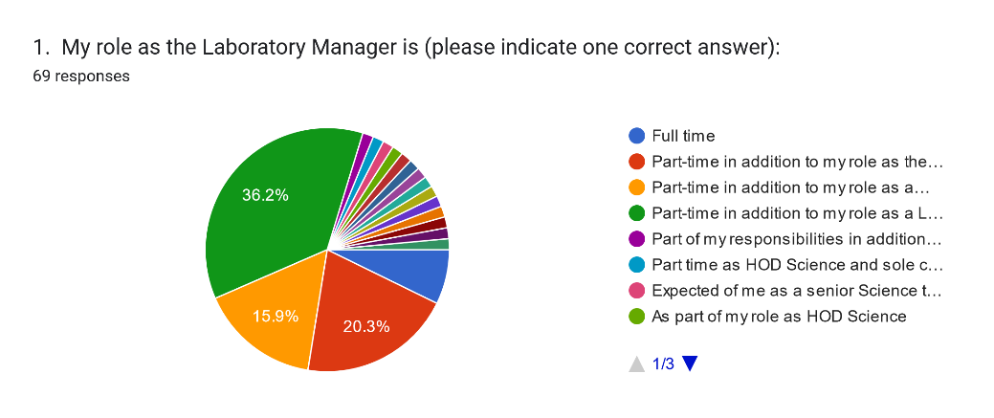
Figure 1 - Responses relating to full vs part-time

Question 2 – Reason for holding the role
- There had been concern expressed that some Laboratory Managers felt compelled to undertake the role because no-one else would, rather than because they had freely chosen to apply for it. Question 2 asked respondents about this aspect and it was found that only 17.4% held the role because they wanted it and applied for it (see Figure 2). All the others are undertaking the role for various reasons mainly based on a strong personal commitment to the need for effective and safe laboratory work as a crucial component of science teaching.
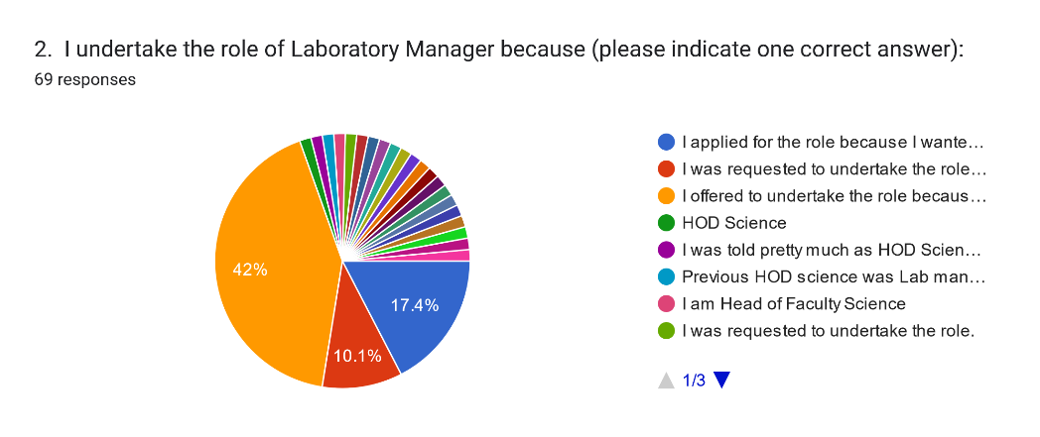
Figure 2 - Reasons for holding the Laboratory Manager role

Question 3 – Time spent on the Laboratory Manager role
- Because the responses were so varied, no graph exists for the responses to question 3 which asked, “Please provide an estimation of the average amount of time in hours that you spend per week specifically on Laboratory Manager activities”. Some respondents were unable to provide a figure because the time they spend varies depending upon many other factors such as teaching workload. Many who did specify a figure did so in a range (1-3 or 4-6 were common). Two respondents reported having less than 1 hour allocated per week as the Laboratory Manager; 30 answers were between 1 and 3 hours per week; 18 were between 4 and 8 and a further 6 reported between 10 and 20 hours per week. Many commented that the time allocated was inadequate to undertake the job properly. Some of the responses are quoted below to highlight the feelings expressed:
- 7 but always approaching things with LM hat on - don't get to turn it off!
- One hour a week - I get a time allowance so I try and not go over it. I could spend a lot more time if I wanted.
- At least 6 hours per week (but allocated time is 2.5 hours per week).
- Less than I should if time was given to this role.

Question 4 – Support from the School Principal
- This question asked Laboratory Managers to respond to the statement, “In my role of Laboratory Manager, my assessment of the support for and understanding of my role from the School Principal is”. This was asked because the Laboratory Manager is a ‘worker’ as defined in s.19 of the Health and Safety at Work Act 2015 (HSW Act) and therefore undertaking duties to assist the Principal (who is an “officer” of the PCBU as defined in s.18(b) of the HSW Act) to fulfil the latter’s far more onerous obligations in an area of the school that has serious inherent risks to the health and safety of staff, students and others.
- 11.6% of responding Laboratory Managers believe that they have active support and a very high level of understanding of their role from the Principal. Another 36.2% believe their Principal offers some support and understanding (see Figure 3). Over half of the respondents do not believe that they have even some level of support or understanding for their role from the Principal. That is tempered by comments made by some respondents that they receive high levels of support and understanding from the HOD (which some suggested was more important).
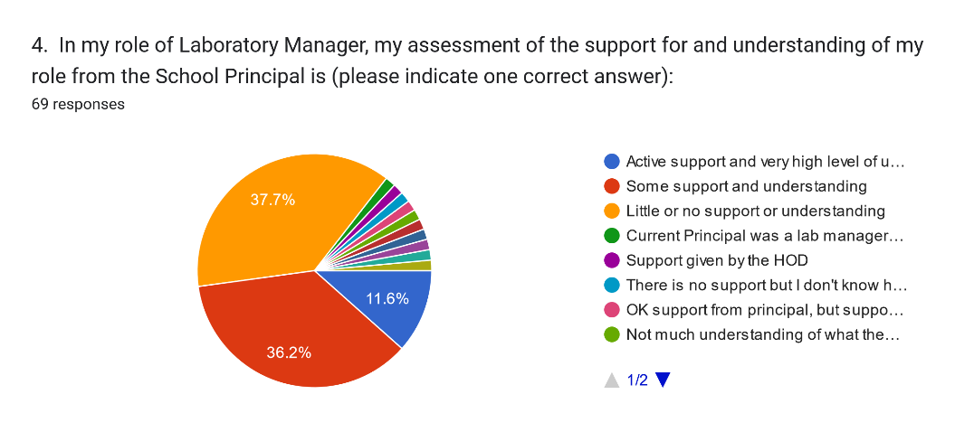
Figure 3 - Support from Principals

Question 5 – Support from the Board of Trustees
- This question asked Laboratory Managers to respond to the statement, “In my role of Laboratory Manager, my assessment of the support for and understanding of my role from the School Board of Trustees is”. This was asked because the Laboratory Manager’s status of a ‘worker’ under the HSW Act (see paragraph 10) who is therefore also undertaking duties to assist the Board of Trustees (each member of the BOT is an “Officer” of the PCBU as defined in s.18(a)(iv) of the HSW Act) to fulfil the latter’s more onerous obligations in an area of the undertaking that has serious inherent risks to the health and safety of people at the school.
- 5.8% of responding Laboratory Managers (see Figure 4) believe that they have active support and a very high level of understanding of their role from the BOT. Another 23.2% believe their BOT offers some support and understanding. Amongst this respondent group, over two thirds believe that they have little or no support or understanding of their role from the BOT.
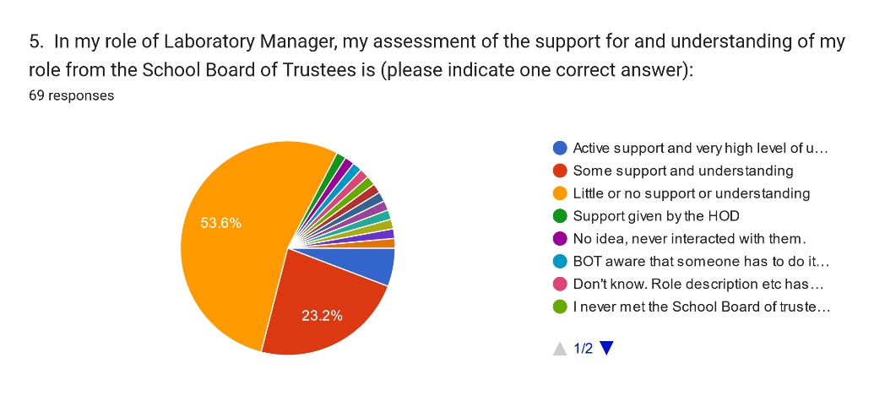
Figure 4 - Support from the BOT

Question 6 – Effectiveness of Ministry guidance document
- The Ministry of Education (the Ministry) has a document for schools entitled, Safety and Science/Pūtaiao - Guidance for Aotearoa New Zealand Schools and Kura. Question 6 of the survey asked, “Please provide a short explanation of your opinion on whether the Ministry of Education document "Safety and Science/Pūtaiao - Guidance for Aotearoa New Zealand Schools and Kura" is an effective description of the accountabilities inherent in the role of Laboratory Manager”. There were some resolute opinions expressed about this document.
- 52% of the responses were positive about the document, albeit some had misgivings about its length or complexity; 27% were either neutral (e.g. said “not sure”) or expressed views that the document was good but had areas where it needed to go further or has critical information missing; and 21% expressed strong negative opinions about the document.
- A limited sample of supportive comments is:
- It is a great document, … .
- It is an accurate description. It encompasses a lot and is a scary role when you start reading the penalties that could be applied.
- It does describe the accountabilities, and hence why no one really wants to take on the position as they see themselves as being the one who has to take all the responsibilities for any issues that arise.
- A limited sample of more neutral comments is:
- It is ok but still prefer the "Guidance to the code of practice" 2015
- The responsibilities are there but more detail is needed for non-scientists.
- Partly - it is better than previous versions. But there is still a lot open to interpretation
- A limited sample of negative comments is:
- I don't feel it is specific enough. lt is too vague, I would like to see the revised edition include specifics such as seen in the code of practice … .
- It makes it scary to be a lab manager. I am not 100% sure where my liability / accountability ends and the classroom teachers starts.
- This document has been incredibly frustrating. … .
- No, the term guidance means that schools who don't want to appoint an LM or invest any money or effort in developing an effective hazardous substance management system in their school, will use the word guidance as a reason for not doing so. Seen it time and time again.
- It is a filthy great document and specific funding for PL should have been tied to its roll out.

Question 7 – Technical skill requirements
- To assess the type and level of additional skills that are used in the Laboratory Manager role, a series of questions were asked. Question 7 was the first of these. It asked, “Please provide a short explanation of the type and level of technical skills that you use as a Laboratory Manager which are additional to those you use in your substantive job (if any)”. Whilst some of the respondents who are chemistry teachers indicated that they already had the necessary technical skills from their substantive role, many others, including specialist chemistry teachers, listed a range of skills and knowledge that was required that is in addition to their substantive role. These are very important to the evaluation of the role so a sample is listed below.
- A better understanding of GHS etc classifications, disposal of chemicals etc
- … specialist safety knowledge e.g. how to clean up/dispose of chemical spills
- Segregation of chemicals/chemical audits in other areas of the school e.g. Workshop / Art
- … hazards, hazard codes and labelling requirements. Having to write safe method of use sheets.
- … provide support in Health and Safety committee
- Specific chemical handling disposal knowledge, a good understanding of chemical properties.
- … responsible management of all Hazardous Substances in line with the MOE guidelines.
- Knowledge of the regulations governing school exempt laboratories. Knowledge of emergency response plan. Familiarity with the Safety and science in schools document. Knowledge of the storage requirements, safe methods of use and Risk Assessments for chemicals used in the school. Maintenance of safety equipment and instruction on its use.
- Risk management assessment skills.
- … we have a little over 400 chemicals at our school which I'm required to know about. i.e. uses, classifications, hazards, tracking requirements, safe storage and safe disposal. My depth of knowledge certainly has increased since I took on this role.
- The use of ChemWatch, RiskAssess, SDS and other hazardous chemical programmes

Question 8 – Communications skill requirements
- Question 8 asked, “Please provide a short explanation of the type and level of communication skills that you use as a Laboratory Manager which are additional to those you use in your substantive job (if any)”. Many respondents pointed out that, as a teacher, communications skills at a high level were an integral part of their substantive job. Some sample comments relevant to the evaluation of the role are recorded below.
- … Ability to communicate safe use and disposal of chemicals used in the school including the products of experiments.

- … effectively communicate information about the hazardous substances and the regulations for Teaching Staff, other technicians and all others who enter the Science Department for any reason. e.g. Maintenance staff, cleaning staff, relief teaching staff, staff from other departments in the school who are using the science labs.
- … clearly and effectively explain why certain hazardous chemicals must be locked away and appropriately stored when not in use. … communicate … to explain why any remedial work needs to be done so that the laboratories and storage locations meet the legislative requirements. … negotiation skills are required. … communicate with the finance department particularly for funding for the removal of hazardous substances which a school no longer needs or more importantly for the removal of hazardous substances which under the new legislation a school should not have.
- Ongoing and persuasion for staff to work to the requirements
- … significant difference between the communication required in my substantive job and the role of lab manager ….
- Good communication skills with the PCUB (Board of Trustees and Principal). … not always comfortable having professional conversations with superiors at this level.

Question 9 – Intellectual skill requirements
- Question 9 asked, “Please provide a short explanation of the type and level of intellectual skills (e.g. planning, problem solving, research and/or analysis) that you use as a Laboratory Manager which are additional to those you use in your substantive job (if any)”. Many respondents pointed out that, as a science teacher, these skills are an integral part of their substantive job. Other comments relevant to the evaluation of the role are recorded below in summary form.
- Planning - use of google sheets/excel to design safety checklists, planning safety induction for new science staff; Analysis - analysis of Safety and Science document, time consuming; Problem solving - risk assessment and management for experiments, particularly those that have potential for harm. Requires high level of thought and problem solving to ensure safety.
- Planning and problem solving in the minimisation of health and safety risk via chemical/biological exposure to science staff and students. Analysing, evaluating and researching new and improved means of handling biologicals/chemicals whilst achieving education targets.
- My ST role does involve quite a high level of problem solving skills and planning but the LM role involves doing much more research and analysis due to the number of resources I need to reference for day to day tasks as LM.
- I am responsible for making the decisions that keep all staff and students safe. All these decisions require very detailed planning, problem solving and research.

Question 10 – Leadership skill requirements
- Question 10 asked, “Please provide a short explanation of the type and level of leadership skills that you use as a Laboratory Manager which are additional to those you use in your substantive job (if any)”. Some respondents pointed out that, as a science HOD, these skills are an integral part of their substantive job. Other summarised comments relevant to the evaluation of the role are recorded below.
- I have had to assert myself with the science teachers and lay down ground rules especially regards health and safety requirements.
- Nil but you have to be a senior person in the department or you will not be listened to - so it is NOT appropriate that the Laboratory Manager be the Technician.
- This is a problematic area especially for those of us who were appointed from a laboratory technician position. Teaching staff are often unwilling to accept my rules for safe use of chemicals and equipment. A great deal of negotiation is required and an ability to stand my ground when I feel it is necessary. Also ability to pick my battles.
- … had to develop quite a high level of leadership skills in order for my teachers, HoD and Principal to listen to what I have to say and obey the safety instructions … . These skills … allow me to be an effective member of the Health and Safety Committee, keeps my staff and our students safe and makes my HoD and Principal listen to me when I raise concerns.
- Being low in the salary and pecking order but being required to educate, provide for and discipline those with higher salaries and status

Question 11 – Physical skill requirements
- Question 11 asked, “Please provide a short explanation of the type and level of physical skills that you use as a Laboratory Manager which are additional to those you use in your substantive job (if any)”. There was not a lot of physical skill requirements that were more than those required to do the respondents’ substantive jobs. The responses to this question mainly involved the need to safely move chemicals etc.

Question 12 – Formal qualification requirements
- Question 12 asked, “Please provide a short explanation of what you believe are: (a) the minimum; and (b) the optimal formal qualifications required to undertake the role of Laboratory Manager to an effective level.” A summary of responses to this question is that the majority believe that a minimum is some form of post-secondary school qualification in science with the optimal being a formal science-based tertiary degree. Within that grouping there were responses that suggested some form of formal Laboratory Manager qualification was necessary and some reported that such a qualification had been available previously.

Question 13 – Formal experience requirements
- Question 13 asked, “Please provide a short explanation of what you believe are: (a) the minimum; and (b) the optimal type and levels of experience required to undertake the role of Laboratory Manager to an effective level”. There were a range of opinions expressed on this question. Most indicated that the minimum experience would be substantial experience in a role that involved chemical handling and in-depth health and safety experience. Like in other responses, there was a strong (albeit a minority) opinion expressed that this role needed to be held by an experienced science teacher not a laboratory technician. In relation to optimal experience there was again a range of expressed opinions (notable one that said, “No idea, but probably more than I have”, and another that said, “NONE because this role is filled by whoever is willing!”). In general, respondents considered that the optimal was experience in laboratory work involving chemicals because of the complexity of that aspect.

Question 14 – Monetary reward received
- Question 14 asked, “Only if the Laboratory Manager role is not your full-time job, how much monetary reward do you receive for undertaking the Laboratory Manager role”. As shown in Figure 5, of the respondents who undertake the role of Laboratory Manager part-time, 35.8% receive no monetary reward at all; 10.4% receive less than $1,000 p.a.; 31.3% receive between $1,000 and $5,000 p.a. So a total of 77.5% of respondents receive less than $5,000 p.a. (gross) for undertaking the role. The remaining 22.5% of respondents receive a variety of payments for the role.
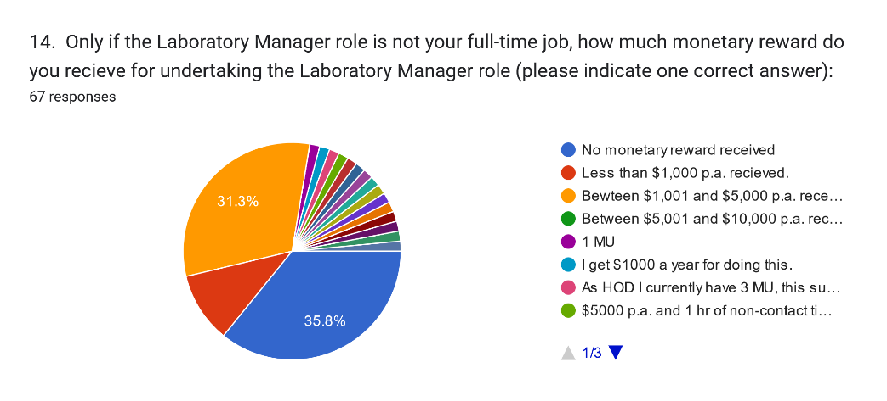
Figure 5 - Monetary reward received

Question 15 – Other relevant comments
- Question 15 asked, “If you have other relevant information that you wish to provide please either write it here or, if it is too much to write here, please email it in complete confidence directly to [Geoff Summers’s email address]”. No email comments were received and one respondent requested a telephone conversation that was held. Of the considerable responses to this question that were submitted, the following are pertinent to the Consultant’s task (it was difficult to minimise this section because the comments were very useful):
- In small schools … it is hard to attract quality science technicians or people of enough experience to take on board the lab managers role, and for principals to justify spending time and money on this position. However, in a small school there is still all the same things to deal with as bigger schools they are just on different scales. Hence it is a job that I currently do not do justice too and I know we are not the only school to be in this situation.
- Schools do not take this issue seriously and only when there is a major event (god forbid) that results in a prosecution will there be any serious attention paid to this.
- The laboratory manager should be a chemistry teacher or full time technician who is given significant time to carry out this role. The Ministry of Education needs to fund the role so schools can staff it.
- I am only Lab manager as I am HOD. … I do not have a time allowance for being Lab manager, I have to fit it in between teaching, being HOD, administrator and the million other things done in a small school. I have had no training or guidance from anyone or anywhere to do this job.
- The greatest problem schools face is there is no clear funding for this position. The operational budget does not include a budget line for this position. The Ministry of Education are providing lip service. This is a worksafe requirement and as such it needs clear funding. The amount of monetary funding should be same for teachers or support staff who undertake this role. I took the job on because it fits well with my role as science technician and none of the teachers wanted to do the role because it wasn't funded.
- Given the new requirements for schools that come into place in April 2024, there is much to do to be prepared for these changes but little time is given due to financial and staffing constraints.
- I feel that the position of Lab Manager is a position of great importance and responsibility, unfortunately I feel many Principals and Boards appoint someone just to "tick" the box. Until they recognize the importance of the role and remunerate accordingly there will always be a struggle to recruit the right people to the position.
- I wish there was a PD program for existing Lab Managers plus NZQA approved Science technicians and Lab Managers program as they do in UK.
- For the responsibilities attached to this role, it is insulting to be expected to accept just a few hours remuneration. My HOD cannot be HOD a just few hours. My Principal cannot be principal a few hours. How schools are getting away with this is insane. There's been no indication of what's an appropriate appointment of time from MOE.

Survey conclusions
- The survey’s responses lead to a concern that the science teaching laboratories in many high schools cannot be guaranteed to have the legislatively required low risk to the health and safety of staff, students and others because of PCBU inadequacies and the lack of recruitment of willing, highly motivated and knowledgeable Laboratory Managers. The Consultant concludes, from considering all the responses to the survey, that there are three interrelated matters that must be addressed. These matters are dealt with separately in this report albeit they are interrelated and all three need urgent unified action.
- The three matters are:
  - A lack of PCBU support means that the laboratory’s health and safety risk in many schools is not being appropriately mitigated as required by the Health and Safety at Work Act 2015;
  - The recruitment systems in place for Laboratory Managers in schools are not resulting in the best person for the job in many cases further exacerbating the health and safety risk; and
  - There is a failure to properly reward the staff undertaking the Laboratory Manager role thereby worsening the recruitment problem and subsequently also the health and safety risk.

Health and Safety
- Health and safety of the laboratory operations must be urgently addressed by all who have responsibilities for it. This relates to the PCBU responsibilities under the HSW Act so is primarily an obligation of the BOT and Principal of the School concerned. Those responsibilities are outlined in s.36 of the HSW Act but other aspects of that law also apply. There are many risks to the health and safety of staff, students and others associated with the operation of any high school, however the school’s laboratory is one of the most serious of those risks and survey respondents highlighted the potential dangerous nature of many of the substances that are an essential part of the laboratory’s activities.

- One comment from a survey respondent was chilling (see paragraph 27) “Schools do not take this issue seriously and only when there is a major event (god forbid) that results in a prosecution will there be any serious attention paid to this.” It must not take a prosecution to effect change in this area, that is too late. A prosecution will only occur once a serious harm incident has already occurred, so a staff member, student or other person at the premises will have been seriously harmed or even killed. The entire purpose of the HSW Act is to ensure that PCBUs actively manage their operations to eliminate risks to the health and safety of all persons associated with the organisation and to minimise any risks that cannot be eliminated; so BOTs and Principals should be taking these matters extremely seriously and actively managing them. The information provided by the survey participants and recorded in this report must result in urgent change.
- The low level of understanding and support that many survey respondents perceived that they receive from their Principal and/or BOT is extremely concerning. The Ministry has obviously not been successful in gaining high levels of understanding by BOTs and Principals of the onerous responsibility that they have as PCBUs in relation to school laboratories. There is an urgent education need highlighted by the survey responses because the current lack of serious incidents can probably be put down to commendable efforts by people who are doing the job often without the required level of PCBU support, sometimes unwillingly and too often without any reward. There is a certain element therefore of chance in the situation and that is unacceptable because the HSW Act requires PCBUs to focus their active attention on health and safety, leaving nothing to chance.
- Some respondents indicated that, instead of understanding and support for their role by the Principal, they receive considerable support from the HOD which they indicated was more useful. That is probably true, the science HOD is often likely to have far more specific chemical and other knowledge that is helpful. However, that does not exonerate the Principal from their responsibility as the PCBU because the HOD does not have that responsibility. The Principal is an Officer of the PCBU and the HOD is a Worker (with much lower level obligations) in terms of the HSW Act.

Recommendations
- The Consultant recommends that the PPTA –
  - Note the survey respondents’ reported lack of compliance with PCBU obligations by many Boards of Trustees and Principals in relation to school laboratories; and
  - Urgently bring this to the attention of: (i) the Secretary for Education; (ii) any PPTA members who are Principals; (iii) any other organisation that represents other Principals; and (iv) the New Zealand Schools Trustees Association; and
  - Remind them all that BOTs and Principals are Officers of PCBUs under the Health and Safety at Work Act 2015 and they have onerous obligations relating to the school laboratories so urgent action is needed to rectify the reported non-compliance where it exists.

Recruitment of Laboratory Managers
- Paragraph 8 and Figure 2 of this report outlines that only 17.4% of responding Laboratory Managers are undertaking the role because they actively wanted it and applied for it. That means that 82.6% are there because of other motivations; including being actively coerced into the role because no-one else would apply (e.g. see paragraph 27 one comment, “… I took the job on because it fits well with my role as science technician and none of the teachers wanted to do the role because it wasn't funded.”). This is seriously concerning from many perspectives, none-the-least being that an unwilling worker is seldom going to be a highly motivated performer in any job and someone taking on the job solely because others refused will hardly ever be the best possible person to do that job.
- Given the health and safety risks to staff, students and others from of the activities of the school laboratory, the Laboratory Manager must be a person who is knowledgeable in all aspects of the laboratory operations and highly motivated to ensure complete compliance with the HSW Act, codes of practice and other controlling documents. The safety of staff, students and others requires the Laboratory Manager to have a robust personal commitment to the task. This role should be designed and rewarded properly so that people with high levels of expertise are motivated to actively compete for the appointment.

- That would require the role to have mana, where the incumbent is highly respected and, importantly in preparing for and operating through emergencies, obeyed because of their status - including by those in more senior positions. The survey indicates that very few Laboratory Manager roles meet even a minimum of these requirements, resulting in a recruitment crises where unwilling and unmotivated staff are often coerced into performing this role.

Job description
- Many respondents who undertake this role in addition to their substantive position mentioned the lack of a proper job description (JD) for the Laboratory Manager role. This is a serious failing for a job that is complex and has serious consequences should it not be performed well. As outlined in paragraph 40 there is a legislative requirement for an agreed set of terms and conditions for undertaking the Laboratory Manager role. Where the employee is operating on an IEA, s.65(2)(a)(ii) of the Employment Relations Act 2000 (ERA) requires, “a description of the work to be performed by the employee” the long standing interpretation of that subsection is that there must be a JD for the work. There is no similar specific provision in the sections covering collective employment agreements (CA), albeit the law allows for any matter agreed between the parties to be part of a CA so s.61(1) of the ERA effectively extends that principle to the Laboratory Manager component of the role. It is long standing practice in human resource management and employment relations for there to be a JD for the work performed under CAs because it is not fair to employees to be asked to complete a job with no employer guidance.
- One of the matters that needs attention in the development of JDs for this role is whether or not it is appropriate for a Laboratory Technician to be the Laboratory Manager. There was considerable comment from science teacher respondents that this was not appropriate and even some technicians who do this role expressed misgivings.

Time allocation
- Laboratory Managers need to be provided with the appropriate resources in terms of time and assistance to complete the role to a very high level of effectiveness. The completely haphazard approach to time allocation that was shown in the survey responses is unacceptable. The Laboratory Manager part of these employees’ overall role must be subject to an agreed set of terms and conditions bargained in good faith under the ERA. Where the employee is a union member and operating under the CA, these additional terms must be agreed under s.61(1) of the ERA and for others it must be a bargained amendment to their individual employment agreement (IEA). In either case there must be documented and agreed set of conditions, that must include the time allowance for undertaking the role because that is legislatively required by s.67C(1)(a)(ii) of the ERA for those on the CA; or by s.67C(1)(b) for those on an IEA. There must then be a sensible reduction in other duties to make space for the laboratory activities which must be bargained and agreed.

Professional development
- Some responses noted that there is little to no professional development provided to assist Laboratory Managers to understand or develop further in their role. E.g. see paragraph 27 where two relevant comments were, “I wish there was a PD program for existing Lab Managers plus NZQA approved Science technicians and Lab Managers program as they do in UK” and “… I have had no training or guidance from anyone or anywhere to do this job”. In the case of a role where there are serious health and safety risks inherent in the work, this indicates a failure of the PCBU in their primary duty of care required by 36(3)(f) of the HSW Act which states:
- Without limiting subsection (1) or (2), a PCBU must ensure, so far as is reasonably practicable,—
…

(f) the provision of any information, training, instruction, or supervision that is necessary to protect all persons from risks to their health and safety arising from work carried out as part of the conduct of the business or undertaking; and

…

Ministry guidance
- The strength of the negative response to the question relating to the effectiveness of the Ministry’s document, “Safety and Science/Pūtaiao - Guidance for Aotearoa New Zealand Schools and Kura” is of concern (see paragraphs 14 and 15 above).
- It was not in the Consultant’s brief to delve too deeply into this aspect, and the considerable science component of the document is not within the Consultant’s expertise profile, suffice to say that the document needs considerable updating, including where possible simplifying, and being made into a code of practice that is a implementation requirement rather than general guidance.

Recommendations
- The Consultant recommends that the PPTA –
  - Work with the appropriate people to completely redesign the role of Laboratory Manager (as outlined in paragraph 36 of this report) to become a career enhancing role that would be challenging but satisfying for staff with appropriate expertise thereby enabling the recruitment of knowledgeable, highly motivated and willing staff to the role; and
  - Work with the appropriate people to prepare a job description for the role of Laboratory Manager, preferably incorporating an ability to take into account differences caused by size, location, full or part-time or other important factors (including whether or not it the role could be undertaken by a Laboratory Technician), clearly providing the role incumbents with the necessary information and authority to undertake the role effectively; and
  - Initiate bargaining under s.61(1) of the Employment Relations Act 2000 for any PPTA members who are Laboratory Managers to document a fair set of terms and conditions for the role including appropriate time allowance as required by s.67C(1)(a)(ii) of that Act; and
  - Work with all authorities that are PCBUs under the Health and Safety at Work Act 2015 in secondary schools to implement s.36(3)(f) of that Act to provide appropriate information and professional development to assist the Laboratory Managers to fully understand and complete their role in a manner that is compliant with all laws and regulations including the development and provision of an appropriate qualification for Laboratory Managers; and
  - Work with the Ministry to update their document, “Safety and Science/Pūtaiao - Guidance for Aotearoa New Zealand Schools and Kura”, preferably greatly simplified, and turned into a compulsory code of practice that, when implemented in schools, would dramatically minimise the inherent health and safety risks of the laboratories.

Monetary reward
- There are many components to reward for work performed. There is of course salary but personal job satisfaction and maintenance of the individual’s career ambitions are also important. The latter two factors are inherently dealt with in the above recommendations so this section is focused on money alone.

Survey outcomes
- Paragraph 26 and Figure 5 of this report outline the situation faced by survey respondents in relation to the monetary reward they receive for undertaking the role of Laboratory Manager. Over 46% of respondents receive less than $5,000 p.a. for the role including nearly 36% who are not paid anything at all. Table 1 displays the range of monetary reward received by those who undertake the Laboratory Manager role in addition to another role in the school.
% of respondents | Annual $
35.8% | $0
10.4% | <$1,000
31.3% | $1,000 to $5,000
22.5% | other
Table 1 - Pay received

- However, if for example a Laboratory Manager was in a well-paid substantive job and the school has agreed to provide a fair time allowance to undertake the Laboratory Manager job, the school and the incumbent might accurately assess that both jobs were ‘worth’ the same rate per hour, in which case not providing any additional pay would be fair. Of course there could be a continuum of circumstances from that example to the exact opposite, so this aspect must be analysed in some detail.
- In general, that analysis requires an evaluation of the Laboratory Manager role and a comparison with the incumbent’s substantive role. This is a little difficult in relation to part-time Laboratory Managers because the substantive roles held by incumbents range from Laboratory Technicians through Science Teachers to HODs. That conundrum will be addressed as the evaluation analysis is reported below.

Evaluation basis
- All job evaluation systems are based loosely on three main components of jobs: (i) what expertise a person will need have in order to undertake the job, usually in terms of knowledge/qualifications and experiences; (ii) what skills/competencies are needed to perform operational activities to the fully competent level; and (iii) the results that the work delivers and the inherent accountabilities for those results. Many job design and description systems logically utilise a similar set of components. The Consultant used a model of job design that fits those requirements to evaluate the Laboratory Manager role. This model has been used by the Consultant to teach job design and description to students on human resources courses at Te Herenga Waka - Victoria University of Wellington and is displayed in Figure 6.
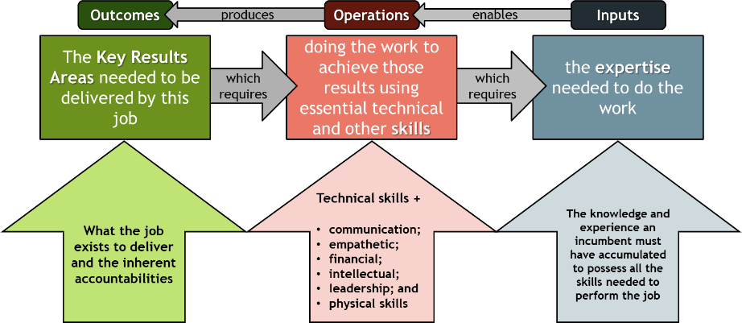
Figure 6 - Simple job design model
- A critical rule of job evaluation is that the job must be assessed when being performed at the fully effective level, so all the Consultant’s analysis and commentary assumes that level of job performance by the Laboratory Manager. The Consultant then assessed all elements initially against what could generally be expected of a generic Science Teacher role (this does not in any way disparage the work done in that role). The Science Teacher job is an obvious standard against which to make this comparison given that many Laboratory Managers are science teachers; assessment against a Laboratory Technician and then a HOD follows to provide a consistent process so reasonable conclusions can be reached.

Key results
- In the Laboratory Manager role, the key results are the many factors outlined in the Ministry guidance and, very importantly, the requirements of the HSW Act. These are onerous and many respondents to the survey highlighted them. E.g. in paragraph 16, “It encompasses a lot and is a scary role when you start reading the penalties that could be applied” and “ … and hence why no one really wants to take on the position as they see themselves as being the one who has to take all the responsibilities for any issues that arise” and in paragraph 18, “It makes it scary to be a lab manager. I am not 100% sure where my liability / accountability ends and the classroom teachers starts”. This proves that many survey respondents were aware that there could be serious consequences for them personally if things go wrong and that is true. However, from a job evaluation perspective, what is more important is the obligation that is placed on the Laboratory Manager to ensure things go well – that is what they are there to do and that is the primary obligation so that is what the Consultant was evaluating.
- Whilst accountability for the actual teaching outcomes flowing from experiments conducted in the laboratory is obviously that of the teacher concerned, the Laboratory Manager is accountable for providing all the necessary substances, processes, systems and procedures, equipment and facilities that are utilised, and then for the procurement, storage, safe handling and eventual disposal of the equipment and sometimes dangerous substances needed for those experiments. So Laboratory Managers are accountable for some serious risks to the health and safety of people at the school.
- The health and safety risks are of course a shared accountability with the BOT and Principal (the PCBU) but as the responsible manager (and therefore a ‘worker’ under the HSW Act) there is a very serious requirement placed on the Laboratory Manager by section 30 of the HSW Act which says:
30 Management of risks
(1) A duty imposed on a person by or under this Act requires the person—
(a) to eliminate risks to health and safety, so far as is reasonably practicable; and
(b) if it is not reasonably practicable to eliminate risks to health and safety, to minimise those risks so far as is reasonably practicable.
(2) A person must comply with subsection (1) to the extent to which the person has, or would reasonably be expected to have, the ability to influence and control the matter to which the risks relate.
- So the law places an onerous accountability on the Laboratory Manager to ensure that hazards are eliminated where reasonably practicable and minimised where elimination is not reasonably practicable throughout the entire laboratory operation, from procurement through usage and disposal of hazardous substances. Whilst it is the PCBU’s responsibility to provide the resources in terms of time, assistance and training to ensure the Laboratory Manager is able to perform this job to that very high standard, it is then the job of the Laboratory Manager to perform the role to that standard.
- The Consultant concludes from this analysis that the key results for which the Laboratory Manager is accountable are in excess of those imposed on science teachers because the latter are entitled to expect the Laboratory Manager to have everything arranged in a manner that enables the science experiments to be conducted safely. That also places these key results and accountabilities well above the normal work of a Laboratory Technician and at a somewhat similar level to a HOD.

Skills usage
- Of the skills categories listed in Figure 6, empathetic skills were not assessed because that is a category which exists for aspects that can be missed in some female dominated occupations such as nurses etc. It is accepted that teachers have a need for this skill but it was not seen as a vital component of the Laboratory Manager job. Financial skills were also not seen as a vital component of this role, albeit there will inevitably be some budgeting and invoice handling undertaken. However, most secondary schools have some form of professional finance assistance available. Also, physical skills were assessed but are not included in this analysis because they were not reported to be onerous.
- In assessing the respondents’ comments relating to the other four skill sets, the Consultant concludes as follows:
  - There are technical skills needed that are in excess of what a Science Teacher should normally be expected to utilise in their teaching role. See paragraph 19 for a sample of the skills that some respondents reported.
  - There are also additional communications skills over and above the teaching skill set. It is accepted that teaching is inherently a communications exercise and high levels of this expertise are required. However, as seen in paragraph 20, there are additional aspects in the Laboratory Manager role such as: enforcing hazardous substances management requirements with teachers and others; influencing the Health and Safety Committee as the primary advisor on laboratory risk matters; influencing others in higher status positions such as the Principal and BOT; and at times negotiating, sometimes with people in more powerful positions, for difficult to obtain outcomes. See paragraph 50 in relation to evaluation approach, so this element has been assessed assuming the Principal and BOT were performing their roles as PCBU effectively in which case the Laboratory Manager would have a need to seriously influence their decisions. These are high level communication skill needs.
  - There are also some additional intellectual skills required over what could be reasonably expected of a Science Teacher as shown in the comments quoted under paragraph 21.
  - Finally, there are additional leadership skills required over what is expected of a Science Teacher, see quotations under paragraph 22.
- The Consultant concludes from this analysis that the technical, communications, intellectual and leadership skills needed to effectively undertake the Laboratory Manager role are in excess of those normally imposed on Science Teachers. That also places these skills requirements well above the normal work of a Laboratory Technician and at a somewhat similar level to a HOD (because a HOD also needs strong influencing and negotiating skills in their normal work).

Expertise requirements
- The respondents’ answers to the question relating to minimal and optimal knowledge/qualifications and experience was, as is nearly always the case, influenced by their own achievements. The Consultant expected this. So the level of knowledge/qualifications and experience required for the expertise profile of the person who can undertake the Laboratory Manager role to the fully effective level was assessed using the skill level requirements. The assessment sought to determine what knowledge/qualification and experience a person would need to have developed those skills to those levels.
- The Consultant concludes that Laboratory Managers need to have completed a tertiary degree in science in order to be able to understand the complexities of the role in its interaction with legislation, codes of practice and other documentation. Laboratory Managers must have an in-depth understanding of all the processes surrounding procurement, use, storage and disposal of chemicals of all types along with detailed understanding of the HSW Act and other relevant legislation and codes of practice. Having completed learning at the tertiary degree level would have instilled the abilities to gain this essential knowledge. A Laboratory Manager must be able to comprehend the complexities of all the legislation, regulations and other requirements so situations can be analysed and the appropriate processes/systems invoked at the appropriate times. Asking someone to do this who is not educated to the tertiary degree level would not be fair to the individual and could even be said to be setting them up for failure in some cases. Of course there will always be the one person who disproves such a rule, but the normal situation requires a tertiary degree.
- The high levels of influencing and negotiating skills that the role needs at the fully effective level, along with the understanding of the implementation of complex legislation such as the HSW Act and others and the ability to intellectualise and implement complex legislative requirements within situations involving serious health and safety risks are all factors that point to the need for high level of education but also the need for a long period operating in or with laboratory systems. This is not a role for the uneducated nor the inexperienced.
- So a tertiary science degree and many years’ experience involving laboratories is the minimum standard for entry into this role.

Overall conclusion on evaluation
- The Consultant concludes, from the above analysis, that the Laboratory Manager role requires a high level of learning and extensive experience and many of the inherent requirements of the role, including the expertise levels, the skills levels and the results to be delivered are similar to what people in senior roles are expected to possess. That leads to a conclusion that the Laboratory Manager requirements are well above what would normally be expected of a Laboratory Technician (accepting that there can be exceptions) and are also a stretch above what should normally be expected of a Science Teacher who relies on others to provide the laboratory activities. Many of the requirements of the Laboratory Manager role are at a somewhat similar level to what a HOD could be expected to possess.
- Some Laboratory Managers are HODs so would be able to undertake this role very effectively according to the above analysis. However, many of them are in the role solely because they could not get anyone else and it is hard to imagine that the very responsible role of Science HOD has sufficient spare capacity to also perform the Laboratory Manager role within the normal working week. Where the HOD has that capacity this would be the logical person for the role and provided they genuinely receive a sufficient time allowance to do this work they probably do not need a significant additional payment over the rate they are already receiving, albeit some recognition that they are saving the school from having to pay someone else would obviously be motivational.
- The above analysis indicates that most experienced Science Teachers could undertake this role, preferably with appropriate professional development provided to assist them. Given that the Laboratory Manager role is evaluated above as being similar in ‘job size’ to a HOD, a Science Teacher taking on the Laboratory Manager role should be provided with adequate time allowance to undertake those duties (see paragraph 44.3) and it would then seem fair that they should be paid an additional rate for the Laboratory Manager component of their overall employment at the difference between their hourly (or daily) rate and the rate of the HOD. This status would also be motivational to the individuals because it would provide them with the necessary mana to do the job and reward them fairly.
- This analysis would also indicate that the role should not routinely be undertaken (as it is now) by the Laboratory Technician - accepting that there will be some technicians who are well educated and very experienced and therefore able to undertake this work. However, where there is a technician who is at the level necessary to do the Laboratory Manager role effectively, they should be provided with adequate time allowance to undertake those duties (see paragraph 44.3) and it would then seem fair that they should be paid an additional rate for the Laboratory Manager component of their overall employment at the difference between their hourly (or daily) rate and the rate of the HOD. This status would also be motivational to the individuals because it would provide them with the necessary mana to do the job and reward them fairly.

Recommendations
- The Consultant recommends that the PPTA –
  - Note that the evaluation that has resulted from the analysis of the Laboratory Manager role is that the role had deliverable results that are at a similar level as would be expected of a HOD in their normal work; that the skill levels needed to complete the work are also at a high level and somewhat similar to those needed by a HOD; and the expertise profile requires a tertiary degree level of education and knowledge of many other vital pieces of legislation and other documentation along with many years’ practical experience with laboratories; and
  - Note that, while it is probably not optimal for the HOD to routinely also be undertaking the Laboratory Manager role, where that does occur and the HOD is given appropriate time allowance to complete the role effectively, the payment at HOD level is probably adequate but some additional payment may be motivational; and
  - Note that where a Science Teacher is undertaking the Laboratory Manager role, provided they have received an appropriate time allowance to complete the work effectively, additional payment for each hour (or day if appropriate) spent on Laboratory Manager work should be at a rate that closes the difference between the person’s normal pay for their substantive role and the pay for a HOD of that school; and
  - Note that, while it is probably not optimal for a Laboratory Technician to routinely also be undertaking the Laboratory Manager role, where that does occur and the Technician is given appropriate time allowance to complete the role effectively, additional payment for each hour (or day if appropriate) spent on Laboratory Manager work should be at a rate that closes the difference between the person’s normal pay for their substantive role and the pay for a HOD of that school.

