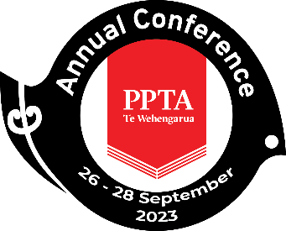

PPTA Te Wehengarua Annual Conference 2023

CONSTITUTIONAL AMENDMENT: REGIONAL NAME CHANGE
A PAPER FROM THE PPTA OTAGO REGION

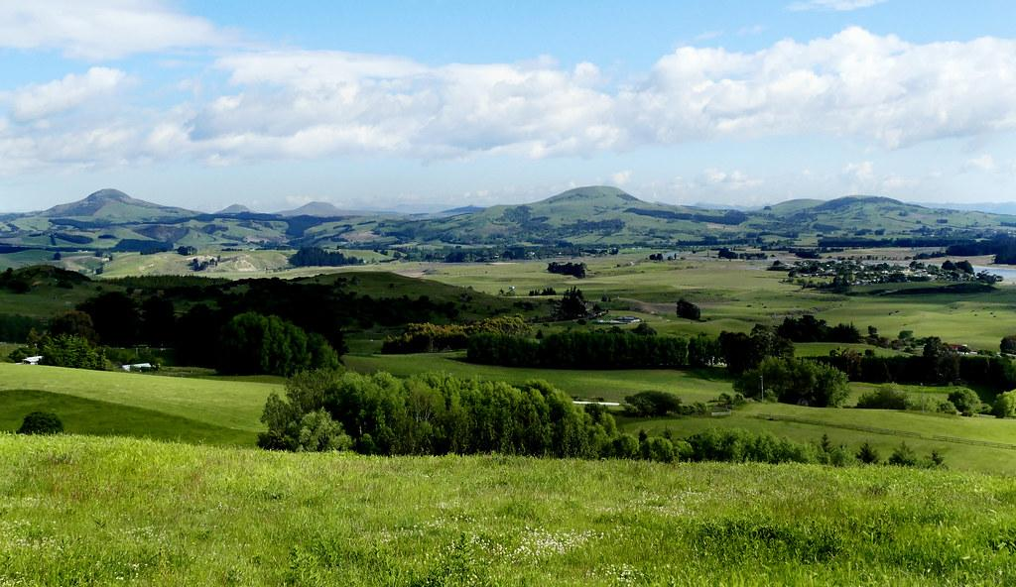

CONTENTS
Recommendations 2
1. Background 5

Recommendations
- That the paper be received.

2. That rule 21 (i) be changed from:

21. (i) Any group of Branches in the same geographical area may by notice to the Secretary apply for registration as a Regional Organisation of the Association and the following Regions shall be the Regions of the Association. (See rule 62 for definition of electoral areas.)
Aoraki
Bay of Plenty
Canterbury
Central Plateau
Counties/Manukau
East Coast
Hauraki Coromandel
Hawkes Bay
Hutt Valley
Manawatu/Whanganui
Marlborough
Nelson
Northland Central
Northland Lower
Northland Upper
Otago
Southland
Tāmaki Makaurau Auckland including the 4 wards established as electoral areas in terms of rule 62 hereof
Taranaki
Waikato
Wairarapa
Wellington
West Coast
Western Bay of Plenty

TO:

21. (i) Any group of Branches in the same geographical area may by notice to the Secretary apply for registration as a Regional Organisation of the Association and the following Regions shall be the Regions of the Association. (See rule 62 for definition of electoral areas.)
Aoraki
Bay of Plenty
Canterbury
Central Plateau
Counties/Manukau
East Coast
Hauraki Coromandel
Hawkes Bay
Hutt Valley
Manawatu/Whanganui
Marlborough
Nelson
Northland Central
Northland Lower
Northland Upper
Ōtākou
Southland
Tāmaki Makaurau Auckland including the 4 wards established as electoral areas in terms of rule 62 hereof
Taranaki
Waikato
Wairarapa
Wellington
West Coast
Western Bay of Plenty

- That rule 62 (i) be changed from:

62. (i) For the purpose of these Rules the following Electoral Areas are hereby constituted: (see rule 21 for definition of Regions)
(a) Northland Upper, Central and Lower
(b) Tāmaki Makaurau Auckland: the 4 Wards of the Tāmaki Makaurau Auckland Region subject to the boundaries for those Wards being ratified by the Executive
(c) Counties/Manukau
(d) Waikato
(e) Hauraki Coromandel/Western Bay of Plenty
(f) Bay of Plenty/Central Plateau
(g) Manawatu-Whanganui
(h) Taranaki
(i) Hawkes Bay/East Coast
(j) Hutt Valley/Wairarapa
(k) Wellington/Marlborough
(l) Nelson/West Coast
(m) Canterbury
(n) Aoraki
(o) Otago
(p) Southland

TO:

62. (i) For the purpose of these Rules the following Electoral Areas are hereby constituted: (see rule 21 for definition of Regions)
(a) Northland Upper, Central and Lower
(b) Tāmaki Makaurau Auckland: the 4 Wards of the Tāmaki Makaurau Auckland Region subject to the boundaries for those Wards being ratified by the Executive
(c) Counties/Manukau
(d) Waikato
(e) Hauraki Coromandel/Western Bay of Plenty
(f) Bay of Plenty/Central Plateau
(g) Manawatu-Whanganui
(h) Taranaki
(i) Hawkes Bay/East Coast
(j) Hutt Valley/Wairarapa
(k) Wellington/Marlborough
(l) Nelson/West Coast
(m) Canterbury
(n) Aoraki
(o) Ōtākou
(p) Southland

BACKGROUND
  - “On 26 December 1848, Sir George Grey, in the New Munster Gazette, ruled that “In compliance with the wish of the Scotch Association for colonising the southern portion of the middle island of New Zealand … the site of their present settlement will, in future, … be designated Otago instead of Otakou”.

  - “Ōtākou is the significant name of the area. Originally Ōtākou is the name of the waterway that spans the area from Te Rae o Tupa, the northern part of Pukekura extending up to the Dunedin port area (where the town resides now) Although it is an ocean harbour, it was known as an awa (river) by our old people because of its river like appearance. Today however, Ōtākou is more widely recognised in the Otago area as the name for the entire harbour and the settlement at the lower end of the Otago Peninsula. Otago eventually became the name for that entire southern region that is a modified version of Ōtākou.”

  - In 2016 the region formerly known as Thames Valley became Hauraki Coromandel in recognition of the customary place name used by tangata whenua and the geographical feature of the area. “Tāmaki Makaurau” became the name of the Auckland region in 2018, in a paper which also included the renaming of the wards to appropriate bicultural names.

  - Tāmaki Makaurau has encouraged other regions to make use of C16/71/25, which is an item tabled at the 2016 annual conference moving that “Te Huarahi and National Executive review the names of regions and wards and titles of elected representatives of the Association to affirm and advance Te Tiriti o Waitangi (the Treaty of Waitangi) as embodied in the First Schedule of the PPTA Constitution”.

  - The Otago region has not been represented by a Te Huarahi representative resident in Otago for at least 15 years. This has likely been the reason why there was no forthcoming action upon the motion from 1.4.

  - The name Ōtākou is already formally used within PPTA Te Wehengarua to indicate the geographical region which the Otago PPTA represents, such as Ngā Manu Kōrero, hui for Reo-ā-rohe and by Te Huarahi.

  - The use of the Māori name reflects support of the language strategy and aspirations of mana whenua, Kāi Tahu.

  - The Otago regional committee has considered this name change, and discussed the move with our branch officers, who requested we seek support from the members as a whole. During our recent PUMs in June, we were able to take a voice vote to determine the support of members for this change. The vote was overwhelmingly in favour of the change, with a minority of members abstaining and even fewer voting against the change.

  - It is with the support and consideration from 1.8 that the Otago region proposes its name be changed from “Otago”, to “Ōtākou”.

https://teara.govt.nz/en/1966/otakou-otago
https://www.otakourunaka.co.nz/tkou-history

