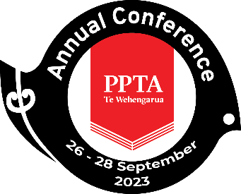

PPTA Te Wehengarua Annual Conference 2023

CONSTITUTIONAL PAPER 2023: AMENDING THE CODE OF ETHICS

A PAPER FROM THE PPTA Tāmaki Makaurau Auckland REGION

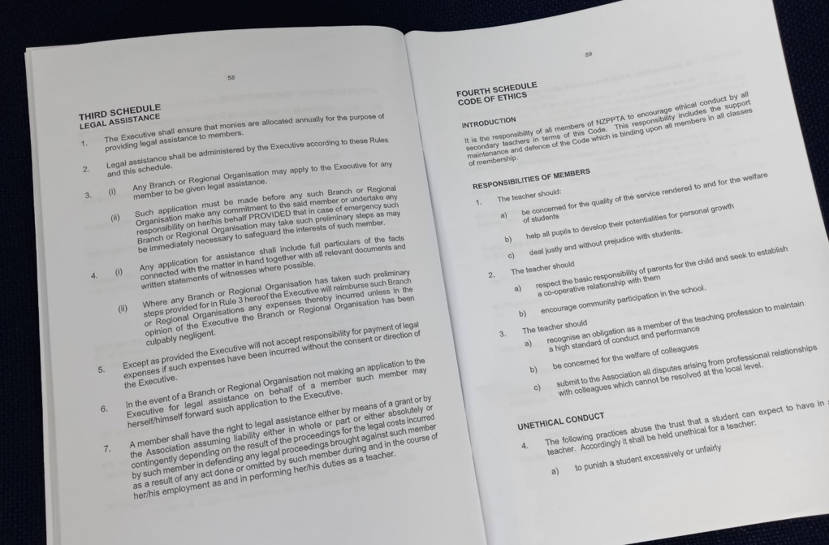

CONTENTS
Recommendations 2
1. Background 3
2. Some Brief History 3
3. Rationale for Change 4
4. Conclusion 5

Recommendations
- That the report be received.

- That the Fourth Schedule Part 6 of the Constitution be changed from:

6. The following practices damage the Association. Accordingly it shall be held unethical for a teacher:
(a) to wilfully disregard any policy decided on by Annual Conferences of the Association or decisions reached by the National Executive
(b) to purport to represent the views of the Association unless authorised to do so
(c) to divulge Association information classified as confidential.

TO:

6. The following practices damage the Association. Accordingly it shall be held unethical for a teacher:
(a) to wilfully disregard any policy decided on by Annual Conferences of the Association or decisions reached by the National Executive
(b) to purport to represent the views of the Association unless authorised to do so
(c) to divulge Association information classified as confidential
(d) to refuse to participate in any lawful industrial action of the Association without exemption.

Background
  - The Fourth Schedule to the Constitution lays out the Association’s Code of Ethics. This is the collectively agreed set of expectations of conduct and discipline that apply to all members, of all classes of membership. The Schedule outlines the roles of the Regional Ethics Committees, the Executive Ethics Committee, and the Ethics Appeal Board when upholding the Code of Ethics. The sanctions available to these bodies when dealing with infringements against the Code are also detailed.

  - Rule 6 in this Schedule outlines practices that are held to be damaging to the collective interests of PPTA Te Wehengarua. The rule currently reads:

6. The following practices damage the Association. Accordingly it shall be held unethical for a teacher:
(a) to wilfully disregard any policy decided on by Annual Conferences of the Association or decisions reached by the National Executive
(b) to purport to represent the views of the Association unless authorised to do so
(c) to divulge Association information classified as confidential.

1.3 This paper seeks to add a part (d) to this rule, making it explicitly unethical to refuse to participate in industrial action unless a proper exemption has been granted. This is the basis of Recommendation 2 of this paper.

Some Brief History
2.1 Throughout much of the Association’s early history, industrial action was rare and there was not an especially strong affinity with the wider trade union movement. Although PPTA Te Wehengarua was founded to be a strong collective voice for secondary and technical education, it was only the radical legislative upheavals of the neoliberal revolution that forced PPTA to formally register as a trade union in 1990.

  - Alongside this legal change was a growing “unionisation” of the Association’s culture. Throughout the 1970s and 1980s in particular, the PPTA became increasingly recognisable as a trade union as well as a professional association and advocacy body. Our increasing willingness to use industrial action has gained guaranteed non-contact time, significant salary increases, and countless other hard-won provisions in the collective agreements. Secondary education in Aotearoa has been improved in countless ways through the collective sacrifice of those who have come before us.

2.3 However, the Code of Ethics continues to lack a specific reference to the mandatory nature of participation in industrial action. In this organisation that now has a proud trade union stand in its history, refusing to participate in a strike or other action is widely considered disrespectful of the sacrifice of one’s colleagues, past and present. It also risks this action being in vain by undermining its effectiveness. This clearly fits with the definition of unethical conduct that damages the interests of the Association. There now exists a chance now to strengthen our dual traditions as a professional association and as a trade union by making this conduct formally unethical.

Rationale for Change
3.1 Industrial action is a unique expression of the Association’s unity, and of its strength. It also requires a unique degree of sacrifice on behalf of our members. It sometimes requires members to give up a portion of the income they rely upon to support their families and build their lives. It almost always requires them to accept a degree of disruption to the education of their students; this is inherently difficult for professionals whose work is dedicated to rangatahi. Sometimes it requires both of these things at once.

3.2 It is for these reasons that New Zealand law and the Association’s Constitution both require that industrial action is approved by a vote of all members who would be bound by an action. This is unusual for Association business, as Conference and Executive are typically empowered to make decisions on matters of policy or action. The Executive does make decisions about dates and details of industrial action, but the mandate approving any action comes directly from the membership. It follows, therefore, that 6(a), making it unethical to disregard Conference policy or Executive decisions, is inadequate in the case of strike breaking.

Future Constitutional Change

3.3 It is important to note that future changes to the structure of the Constitution are coming as a requirement of the Incorporated Societies Act 2022. Among other changes, this updated legislation requires that the Constitution contains provisions for a member complaints process, so it is likely that the Code of Ethics schedule will require a rewrite.

3.4 It could be argued that a change such as the one proposed in this paper could be presented to the 2024 Annual Conference as a part of an ‘omnibus’ set of changes to the Constitution as required by law. However, a change to recognise the importance of industrial action in our rules is timely now. In 2022 and 2023 we have seen a more difficult-than-usual industrial round, requiring multiple days of strike action and several other forms of industrial action. This has crystallised the importance of solidarity in pursuit of our collective aims.

3.5 When the Association’s Constitution does undergo this revision process, it ought to be up to date in matters of substance. The Incorporated Societies Act changes will change the form of our rules, but we must start this work with an existing Constitution that lays out conduct that we do not condone. Updating the Code of Ethics to recognise the unique importance of industrial action will ensure that any future amendments start from a solid base that reflects our history, values, and priorities.

Conclusion
4.1 PPTA Te Wehengarua was founded on and relies upon the principle of solidarity. This concept is a powerful bedrock value of the union movement, and it underlies our strength in Aotearoa and around the world. As we have transitioned from a purely professional association to one that also has a distinct trade union character, our understanding of the meaning of this principle has evolved. It is time that our Code of Ethics reflects this. Our professional credibility is underpinned by our industrial strength, and vice versa. The governing document of the Association needs to lay out this principle and make it clear that Association members must participate in industrial action approved by the democratic action of their colleagues.

4.2 Our Association has an enviable record of unity in action, and this change is not intended to simply be punitive. It is hoped that the provision proposed in this paper would be needed only sparingly. Implicit in any requirement to participate in industrial action is also the expectation that the Association makes this as achievable as possible for members, including through the well-developed exemption and hardship processes that regions already run. However, it is often said among PPTA members that our rules and our process keep us safe. They can only do this if they are constantly updated to reflect our values. It is time to update the Code of Ethics to reflect how important unity is to PPTA Te Wehengarua and our collective cause in times of industrial action.

Grant, David. (2003). Those who can teach: A history of secondary education in New Zealand from the union perspective, pp. 174-175. Wellington: Steele Roberts.
Grant (2003), Those who can teach, pp. 167-178.

