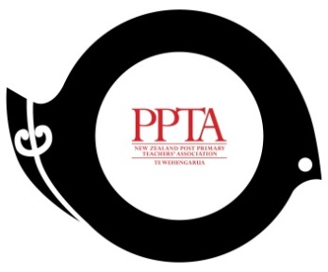

PPTA Te Wehengarua Annual Conference 2018

TIME to review and strengthen PPTA’s TREATY RELATIONSHIPs
EVERYTHING WORTHWHILE TAKES CONSIDERABLE EFFORT
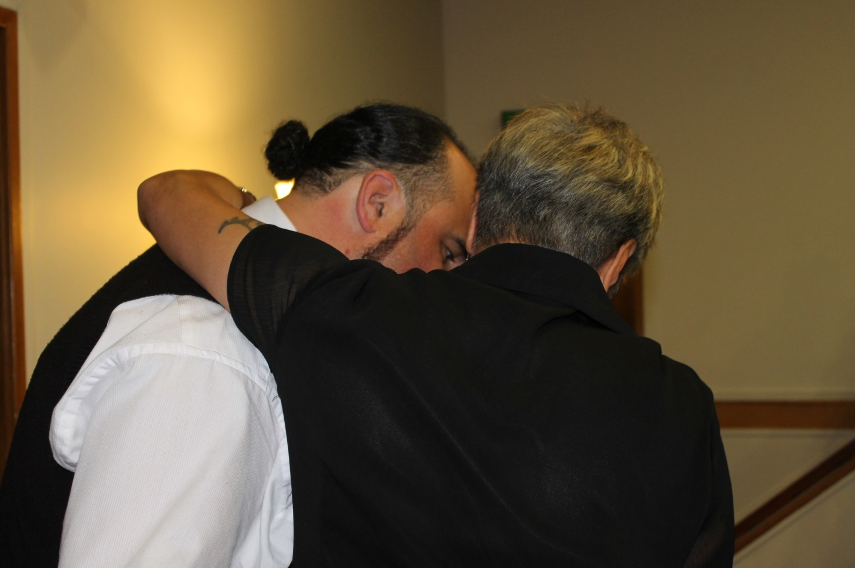

2020 will mark 20 years since PPTA undertook its last Treaty Audit.
This paper outlines the PPTA’s history of Treaty relationships, discusses the current situation and proposes another audit be conducted, and reported to annual conference in 2020.

recommendations
- That the report be received.
- That a Treaty audit of PPTA structures, policies and practices be carried out in 2019, and a progress report and recommendations be presented to the 2020 conference for membership consideration.
- That the PPTA continue to encourage branches to provide opportunities for members to promote and share culturally responsive and relational pedagogy practice.

wHAKATAUKĪ:
He ora te whakapiri, he mate te whakatakariri
There is strength in unity, defeat in division

introduction and purpose
  - Te Huarahi Māori Motuhake invited Māori constitutional lawyer Dr Moana Jackson to a hui in November 2017 to share his insights into the Treaty of Waitangi within the PPTA. He provided an overview of his connections and involvement with the Association over a number of years. This was followed by an interactive session of reflections on the Treaty of Waitangi and the road ahead. Dr. Jackson explored some of the words used around the Treaty discourse over recent decades, and the ongoing impact of subtleties in the meaning of the words; for example, in the difference between words like “partnership” and “relationship”.
  - Next year will mark 20 years since the PPTA Constitutional Review (He Huarahi Hou) was initiated and gave rise to significant milestones that saw the establishment of PPTA’s partnership body, Te Roopu Matua, and the position of Te Mataroa to service the needs of the broader union membership. Te Huarahi’s 2017 conference paper, Whānau, Hapū, Iwi, Māori Communities and Schools Working Together – Mā Te Mahi Tahi, Ka Ora Ai Te Taitamaiti set the trend for working together to support Māori student success. Te Huarahi wishes to continue this flow of dialogue within the membership to help create a living tapestry of the Treaty journey that tells our ongoing story.
  - Te Huarahi therefore proposes that the PPTA revisit
- What it is doing in its Treaty relationship with Māori members
- What a Treaty relationship means for both Māori and Pākehā members of the PPTA
- What it means when we talk about a Tiriti relationship rather than a Tiriti partnership
- How the PPTA can continue to explore and give effect to our Treaty goals, aspirations and obligations to build collaborative relationships and mana enhancing partnerships

background

  - The Association is committed to the concept of genuine partnership as a constitutional goal included in the third object in Rule 4(c):
To affirm and advance Te Tiriti O Waitangi (The Treaty of Waitangi) as embodied in the First Schedule of these rules.
  - Through the acceptance of this commitment and to give effect to that goal, structures and processes have been developed to enable Māori to achieve Tino Rangatiratanga in respect of their needs, both educationally and as members.

  - The key elements of that structure are:

Te Huarahi Māori Motuhake

Te Huarahi's role is to advise Māori members and to act as a channel for their concerns; to consider and represent those concerns to Executive; and liaise with Māori members, particularly the regional Te Reo-ā-Rohe network. Te Huarahi has responsibility for making decisions which impact on Māori members.
    - Where Executive or Te Huarahi wishes to resolve a question about Ngā Take Māori, a group consisting of Te Huarahi's representatives and an equal number of Executive members meet to find an appropriate solution.

Te Reo ā Rohe
Te reo ā rohe officers are elected Māori members with responsibilities within regions to build relationships and lines of communication between Māori teachers. They promote Māori education and further the interests of Māori teachers, students and parents.

2.3.4. PPTA Kaumātua and Whaea
The Kaumātua and Whaea are chosen by Te Huarahi to assist and support Association matters and participate in all aspects of the PPTA.

2.3.5. Āpiha Māori and Kaitā Rongorua
The Āpiha Māori and Kaitā Rongorua are employed to support Māori membership and develop a special relationship with those structures.

Historical perspective

  - In 1978, Hamiora Tangiora chaired the open sessions on the marae ātea of Waahi Marae where, as a Multicultural Education Advisory Committee member, he worked to address the needs of Māori education.
  - In 1986, the PPTA Conference affirmed its commitment to the Treaty of Waitangi and passed a resolution directing a review of the PPTA’s structures and policies in response to meeting the needs of Māori.
  - In 1987, the PPTA Conference amended the Constitution which affirmed its obligation to
- Work for improvements in education to address present deficiencies
- Protect actively, to the fullest possible extent, Māori values and Māori taonga (including Māori language and customs)
- Ensure equity for Māori in education
- Appoint the first Āpiha Māori.
  - Te Huarahi means the pathway; Māori Motuhake means specially or absolutely Māori. Te Huarahi Māori Motuhake was the name chosen by the PPTA’s first Kaumātua, the late Hamiora Tangiora, just months prior to his death in May 1988.
  - In 1988, Te Huarahi Māori Motuhake and the Kōmiti Pasifika replaced the Multicultural Education Advisory Committee and Te Wharekōtua Turuwhenua became the Association’s Kaumātua. The role of the Whaea was established and the Māori Electoral roll was introduced.

Our current situation

  - In preparation for this conference paper, Te Huarahi set up a working group to collect data from a representative sample of participants amongst PPTA staff and elected representatives within Te Huarahi Māori Motuhake, national executive, regional chairs, branch chairs and the general membership. The writing group was keen to point out that there was no right or wrong answer, and that they were interested in what people really thought about this kaupapa.
  - The aim was to gauge a snapshot of responses to the following questions:
- What do you understand a Treaty relationship is?
- What do you think the PPTA Treaty relationship is?
- How important are Treaty relationships to you?
- How do you make it real at work and/or within PPTA structures?
- What does the PPTA do well?
- What could the PPTA do better?
  - A snapshot of responses can be found in Appendix 1.

our vision for the future of ppta

  - Te Huarahi Māori Motuhake wishes to build on the unique place of tangata whenua as the first people of Aotearoa. Within the context of the PPTA, that means we must continue to honour our obligations to one another under the Treaty of Waitangi, through whanaungatanga and making connections based on relationships of trust and purposeful engagement.
  - It is time we revisited our progress as a union. There are things that we should recognise as achievements, and we should take the time to celebrate those. There are opportunities for us to look backwards as we walk further into the future.
  - As an organisation of members and staff we need to create an authentic and non-threatening space where we can learn from each other. In terms of advancing mātauranga Māori, we should work on increasing our awareness of issues and how we can engage with them.
  - The mark of humility and respect is in acknowledging that not all aspects of te ao Māori are for giving away to others. In writing this paper, Te Huarahi Māori Motuhake wish to gift our whakaaro to the membership and invite you to support the process of a review of the PPTA’s Treaty relationship with Māori.
- How is our Treaty relationship doing?
- What does it mean for Māori members and Pākehā members in the PPTA?
- How fluid is this relationship? Is there a tuakana/teina junior/senior relationship?
- What is viable in the short term and long term process if this is not a priority for members?
- Do we need to increase membership awareness through regular message of focus?
- Can we support and encourage members to take a more active role in the Treaty relationship?
- Should we revisit the Constitution?
- What needs to happen so members feel like a Treaty relationship is a good relationship?
- How do we acknowledge the extra mahi of Māori members?
- Are we aware that equality is not equity?
- How do we address the everyday grievances and dismissals of te ao Māori?
- How are we doing in terms of our progression as an Association?

FIGURE 1. MAKING MĀORI METAPHORS MEANINGFUL
Use this framework to unpack what you know about these Māori metaphors, consider the critical questions and in response to these questions identify answers, implications and possible actions for engaging with whānau, hapū and iwi.
What do you understand by these metaphors? | With these understandings in mind what are the most critical questions?  What other questions are relevant? | Answers & Implications? | Possible Actions and Timelines
Mana whenua | How well do you know the land upon which the school is built? What do you know of its historical custodians? What are the links to your Māori students, and to other iwi?
Kanohi kitea | How often are you seen by local iwi at their functions? Why is this? What functions do you know about? What functions do you attend? Why? Why not?
Whakawhanaungatanga | What opportunities are there to begin to develop formal cultural connections with these people?
Koha | What does your school currently provide as your koha to these communities? What could/should you be providing as your koha?
Mahi tahi | How has your school collaborated with local/other iwi? How are you currently collaborating with local hapū and iwi/other iwi?
Kotahitanga | How do/can the goals and aspirations of the school align with those of the whānau, hapū iwi? What will it take to get a more aligned approach? What benefits might this bring?

This resource is part of the Te Kotahitanga ebook collection. A section of this ebook can be accessed through the Ministry of Education. Education Counts website at http://educationcounts.govt.nz/topics/bes/resources/te-kotahitanga-ebook-collection.

Appendix: responses from survey participants
A Treaty relationship
- Occurs when the parties involved wish to have a peaceful co-existence with one another and create a document setting out the terms of that agreement
- Exists between two parties who have signed for the mutual benefit of both parties. In the New Zealand context, it is the relationship between Māori and non-Māori where both acknowledge the rights of Māori and non-Māori under the Treaty of Waitangi
- Is an active and ongoing partnership that exists between Māori and others where the principles of the Treaty are honoured
- Is the “partnership” between Māori and the Crown that still needs to be seen by the Crown as a partnership
- Is a partnership between Māori and others to share New Zealand so that two cultures could co-exist in close proximity while each holds responsibility for their own ideals and way of life (didn’t quite work out that way though)
- Recognises the Treaty as the founding document of Aotearoa/New Zealand. The Treaty states how Māori and the Crown will work together in a partnership model
The PPTA Treaty relationship
- Recognises that Māori are Tangata Whenua and, while integrated into a European-based education system, there must be a recognition of cultural norms for Māori learners
- Is a step in the right direction, and one that the Crown should acknowledge and learn from
- Is one where the PPTA is contributing significantly to the education of others
- Actively adheres to and honours the principles of the Treaty including te tino rangatiratanga, and this is manifested through Te Huarahi
- Is an acknowledgement of the Treaty and a commitment to partnership, with Te Huarahi and Māori in the wider sense, and an understanding of the institutional structures that have led to consistent historical denigration of Māori culture and our people
- Is laid out in the PPTA Constitution that affirms its commitment to genuine partnership as embodied in the Treaty
Treaty relationships
- Are extremely important, ongoing and must be nurtured
- Both are a pathway and method for operating into the future.
- Suggest that New Zealand can be special and stronger in the world by having cultures co-exist in cooperation with each other
- Encourage me to want to learn what I can of other cultures, other languages and embrace parts of those cultures that work for me
- Continue to shape my whānau and our future
- Require that real changes are made for Māori, not just lip service to the treaty or cultural practices
It is acknowledged that the media has the capacity to undo positive movement forward, that the Treaty is a living document and the PPTA Constitution is too, and that 1840 was the founding point for Aotearoa and 1987 the way forward for the Association.

Making it real at work and/or within PPTA structures:
- Not at the forefront of my mind, I am lucky enough to work in a school that has woven the principles into our school values, the same with the PPTA, a lot of the core principles govern my dealings within the PPTA
- You make the Treaty relationship your modus operandi, as an example Te Huarahi and Executive are working together on PPTA’s response on the review of Tomorrow’s Schools
- In our school we take elements that are important for Māori and the Anglican Church and have them both occur
- Maintaining positive relationships with colleagues, educating others on tikanga, providing advice on kaupapa Māori, valuing and respecting elders and senior colleagues
- Difficult in my subject area
- Using the content of Mahi Tika courses, using te reo.
PPTA does well
- In meeting protocols, culture is a taonga
- With Ngā Manu Kōrero, National Māori Teachers Conference, tikanga Māori, Treaty workshops
- Keeping members’ wellbeing at heart, supporting and informing members
- In acknowledging the importance of partnership as being a relationship
- Upholding te reo and tikanga
- In supporting a self-governing Māori Executive, with autonomy over Māori budget lines, Te Rautaki, leadership roles in Ngā Manu Kōrero, Kapahaka, Āpiha Māori, Te Mataroa, Treaty workshops, te reo and tikanga Māori
PPTA could do better at
- Easing Māori teacher workload, promoting our strengths in kaupapa Māori and professional development for/in kaupapa Māori, showcasing our role in Māori student successes
- Promoting te reo Māori
- Supporting kaiako in Area Schools (relationships)
- Supporting members with everyday problems, not just high profile cases
- Facilitating greater coverage of Māori issues, encouraging more te reo usage, instituting compulsory Treaty workshops for staff, and creating structures that can be more effective for our treaty partnership

