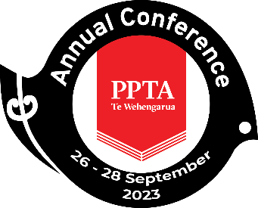

PPTA Te Wehengarua Annual Conference 2023

Report: Curriculum and NCEA update

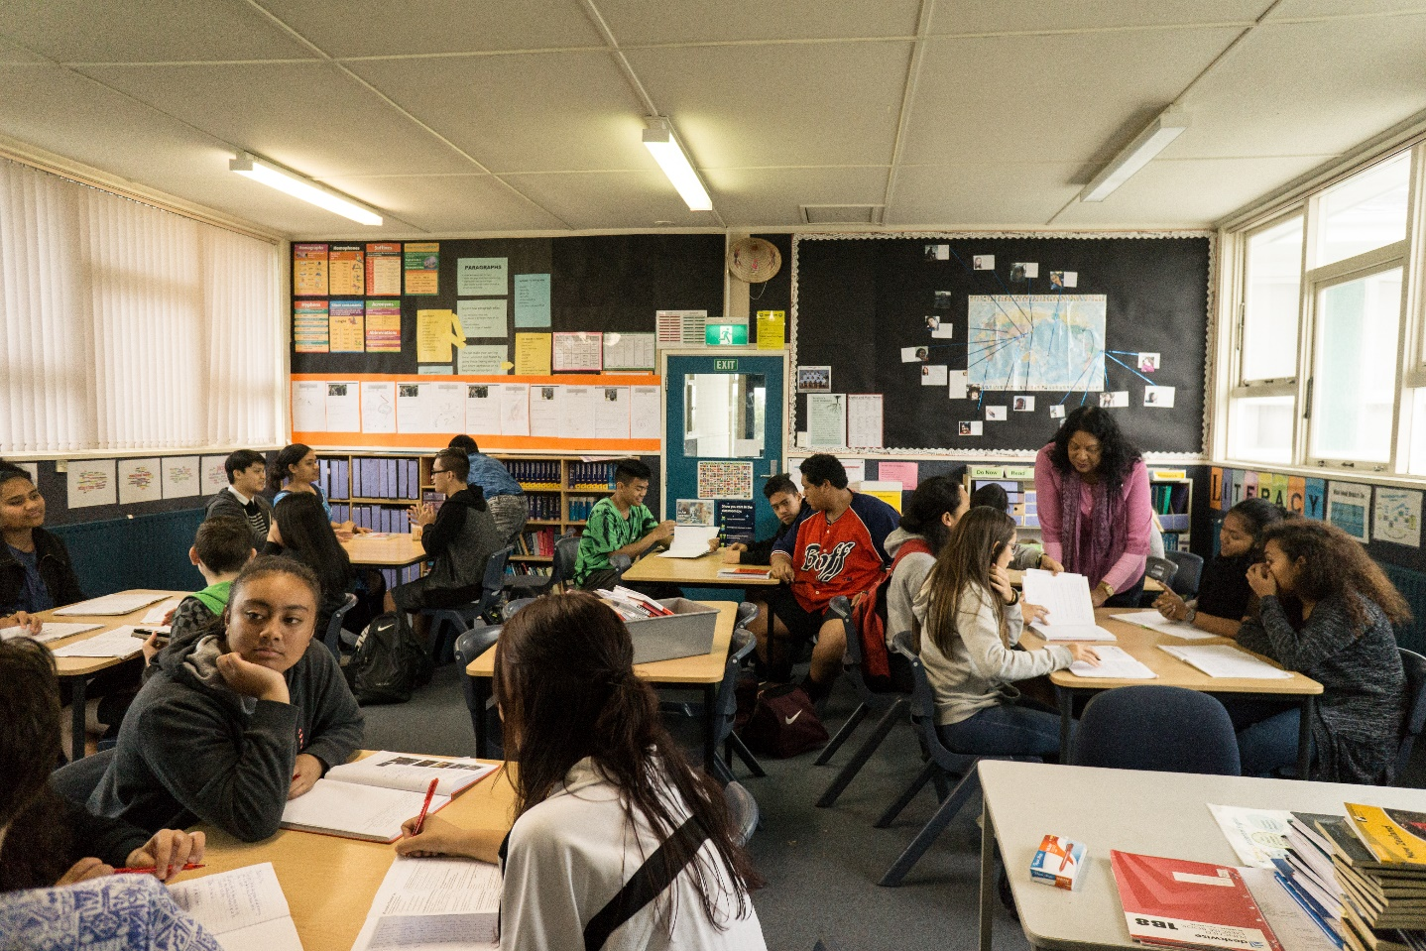

CONTENTS
Recommendation 2
1. Fighting for a pause 3
2. Success, of sorts 4
3. Ongoing advocacy 5

Recommendation
- That the report be received.

Fighting for a pause
  - At the 2022 Annual Conference members unanimously passed the paper recommending a pause on the Review of Achievement Standards (RAS) to allow for curriculum alignment. The paper also recommended that PPTA Te Wehengarua advocate for a focus on mana ōrite mō te mātauranga Māori, cultural responsiveness, literacy & numeracy and localised curriculum in the existing teaching, learning and assessment programmes. Since then, Executive members, member committees and staff were concerted in their efforts to share these recommendations through every opportunity. The following provides an overview of what happened next:
November 2022:
- The Ministry started to take notice and called a meeting of the secondary members of the Curriculum Voices Group to better understand PPTA Te Wehengarua’s position. While the Ministry acknowledged that better alignment between and communication about the NCEA Changes and the Curriculum Refresh programmes were needed, they were not prepared to reconsider any timelines.
- Letters were exchanged with the Ministry about the PLD supports that would be available as the RAS and Curriculum Refresh unfolded over the next 3-5 years. PPTA Te Wehengarua remained unconvinced of the Ministry’s commitment to supporting the needs of the secondary sector and specialist subjects.
- PPTA Te Wehengarua’s own Curriculum Advisory Committee met to look at possible timelines should a pause to the RAS go ahead, and discussed a range of possibilities including whether industrial action should be considered if a pause was not achieved. Key messages for media were agreed upon including the importance of the Curriculum Refresh being the FIRST STEP in reviewing our assessment system.
December 2022:
- A meeting occurred between PPTA Te Wehengarua and Senior Ministry officials to discuss the importance of subject specialist support with further acknowledgement by the Ministry of less-than-ideal communications with the sector to date. We were informed that National Implementation Facilitators (for NCEA) would not cover all subjects and that these NIFs would be there to support up to five subjects each within their region.
- PPTA Te Wehengarua submitted an Official Information Act request to the Ministry of Education requesting detail of NCEA implementation plans, advice received about rollout and workload implications, budget and contractor details.
Early 2023:
- In the absence of any response from the Ministry of Education regarding PPTA Te Wehengarua’s call for a pause to the RAS, and with no response to the OIA request forthcoming, a new plan was needed to keep up the pressure on the Ministry. The PPTA Te Wehengarua therefore set out to gain some more targeted input from members about their experiences with the NCEA pilots (including literacy and numeracy) in order to be ready with some data for our next round of meetings with the Ministry.
- In Term One, the necessary priority for all members was on industrial action over the unsettled Secondary Teachers’ Collective Agreement, so, in the NCEA/Curriculum space it was decided to focus our efforts on events where member voices could easily be gathered (Issues and Organising Seminar, Subject Associations Forum) and through a call for volunteers to take part in a pilot feedback project.

  - PPTA Te Wehengarua acknowledges there is a significant amount of work being done by teachers in the pilots, as well as in some cases huge costs being carried by schools - given that the time the pilots take to prepare for and implement, both in and out of school, is generally not resourced.

  - While we acknowledge that the purpose of the pilots is to highlight issues so they can then be resolved in subsequent assessments, the feedback we heard was a validation that everything was moving too fast and schools, kaiako and ākonga needed more time to get their heads around the changes involved in the Review of Achievement Standards. We also heard that:

- the impact on teachers’ workload is huge;
- there is still little understanding of where the focus on the Curriculum Refresh needs to fit (especially given many subjects are left in the dark for another couple of years);
- the logistics of administering the literacy and numeracy assessments are a major concern;
- diverse learners are disadvantaged by digital assessments (if that’s the only way of demonstrating competence);
- there is insufficient support for exemplar development and that there is an over-reliance on Subject Associations (who may not have the capacity/capability or funding to sustain this mahi);
- there has been little or no whānau/student voice sought.

  - Input from members was also sought through a range of Association committees, including the Middle Leaders and Senior Positions Advisory committees and the Secondary Principals’ Council for us to ensure that the voices of teachers and senior leaders are gathered and subsequently re-told at relevant opportunities.

Success, of sorts

  - 19th April 2023 – PPTA Te Wehengarua welcomed the government’s announcement for the delay to the implementation of NCEA levels 2 and 3 and for the provision of the two-year transitional period for the literacy and numeracy co-requisites.

  - As a result of the announcement, we asked a number of questions about what the delay means in easy-to-digest messages and the Ministry have provided updates to the NCEA webpage. We also understand that:

- text-to-speech will be available to all students participating in the Literacy (writing) and Numeracy assessments. Ministry will provide further information about whether text-to-speech undermines the reading standard once a research report has been received.
- NZQA continues to pilot and assess the use of other assistive technologies in assessment.

Ongoing advocacy

  - PPTA Te Wehengarua acknowledges that there will be ongoing changes to teaching, learning and assessments over the next few years that will impact on all of its members.

  - The Executive and staff will continue to:

- represent the voices of the membership
- question when changes (and timelines) are not thoughtful and coherent
- advocate for quality resources and professional learning opportunities that are relevant and accessible, and which provide outcomes that meet the needs of our ākonga
- ‘visibilise’ the significant work and workload carried by teachers and schools.

3.3 PPTA Te Wehengarua will continue to fight for quality public education and will not lose sight of the needs of our ākonga and kaiako, and we are not alone in our concerns: In the words of Bali Haque (MNZM) who was chair of the 2018/19 Tomorrow's Schools Independent Taskforce,

“...we have been here before. Governments over the last 30 years have tried to address the same problems we are trying to fix today, and consistently failed...The current batch of changes are incoherent, poorly planned, with impossible timelines, and will fail.... To make matters worse, the curriculum centre which was to lead this work was effectively established after most of the key decisions were made. Furthermore, changes to the NCEA have been made independently of the refresh – as if NCEA assessments have no relevance to the school curriculum.

https://www.beehive.govt.nz/release/new-maths-and-literacy-assessment-prioritised-other-ncea-changes-slowed
https://ncea.education.govt.nz/understanding-how-ncea-requirements-are-changing
https://www.stuff.co.nz/taranaki-daily-news/news/300930633/school-education-reforms--lots-of-churn-and-continued-decline

